**Lesson 2 – Finding Limits from Graphs**

When trying to evaluate , we are looking for the value that *f* (*x*) approaches as *x* approaches *a*. We can often read this from the graph by looking for the value that the   
*y*-coordinate approaches as the *x*-coordinate approaches *a*.

**PART A:** Consider the graph of 

1. 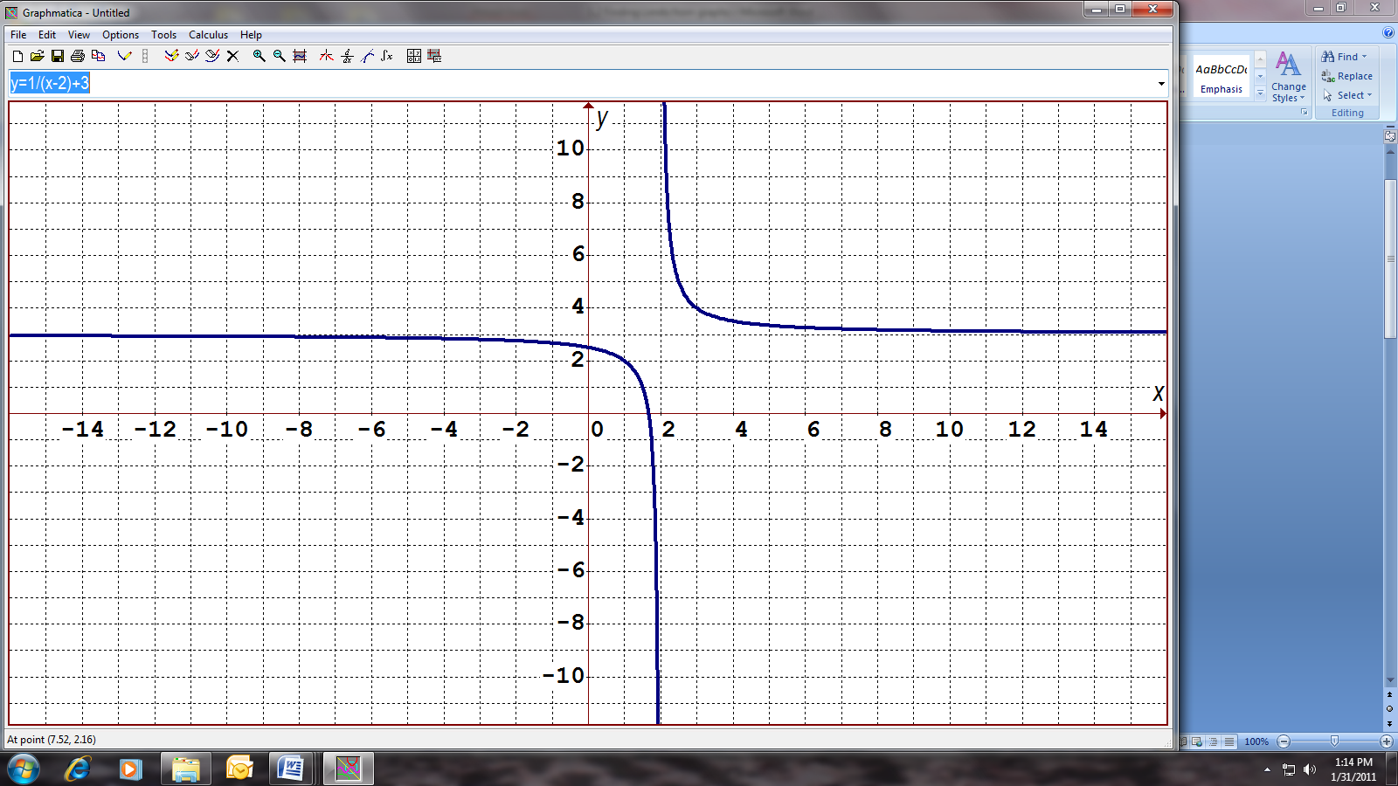  
   because as the *x*-coordinate approaches 1 (either from the left or the right), the  
   *y*-coordinate approaches 2.
2.   
   because as the *x*-coordinate gets infinitely large but remains positive (towards the right), the *y*-coordinate approaches 3.
3.   
   because as the *x*-coordinate gets infinitely large but remains negative (towards the left), the *y*-coordinate approaches 3.
4.    
   because as the *x*-coordinate approaches 2 from the right (above 2), the *y*-coordinate gets infinitely large, but remains positive.
5.    
   because as the *x*-coordinate approaches 2 from the left (below 2), the *y*-coordinate gets infinitely large, but remains negative.
6.  DNE (does not exist)  
   since the limit when you approach 2 from the right is different than when you approach from the left.

We can now state one of the properties of limits:

In order for $\lim_{x→a}{f(x)}$ to exist, one of the conditions is that $\lim_{x→a^{+}}{f(x)}=\lim_{x→a^{-}}{f(x)}$

**PART B:** Homework

For each of the following questions, first sketch the graph of the function, then evaluate the limit by looking at graph. Note: This is a good review of your Grade 12 Functions!

|  |  |  |  |  |  |  |  |  |  |  |
| --- | --- | --- | --- | --- | --- | --- | --- | --- | --- | --- |
| 1. |  |  |  |  |  |  |  |  |  |  |
| a) |  |  | b) |  |  | c) |  |  |  |  |
|  |  |  |  |  |  |  |  |  |  |  |
| 2. |  |  |  |  |  |  |  |  |  |  |
| a) |  |  | c) |  |  | e) |  |  |  |  |
| b) |  |  | d) |  |  | f) |  |  |  |  |
|  |  |  |  |  |  |  |  |  |  |  |
| 3. |  |  |  |  |  |  |  |  |  |  |
| a) |  |  | c) |  |  |  |  |  |  |  |
| b) |  |  | d) |  |  |  |  |  |  |  |
|  |  |  |  |  |  |  |  |  |  |  |
| 4. |  |  |  |  |  |  |  |  |  |  |
| a) |  |  | b) |  |  | c) |  |  | d) |  |
|  |  |  |  |  |  |  |  |  |  |  |
| 5. |  |  |  |  |  |  |  |  |  |  |
| a) |  |  | c) |  |  | e) |  |  |  |  |
| b) |  |  | d) |  |  | f) |  |  |  |  |
|  |  |  |  |  |  |  |  |  |  |  |
| 6. |  |  |  |  |  |  |  |  |  |  |
| a) |  |  | b) |  |  | c) |  |  | d) |  |